RavenDB Server Console – Spec

This document is meant to outline the server console specification for RavenDB.

The server console is meant to provide administration support for a RavenDB server and is part of the RavenDB Enterprise work. Note that it is not meant to replace the RavenDB Management Studio; the studio is providing access to a single database and its document. The server console is meant to provide access to the whole server and management of databases, users and management of the whole server*.*

# Databases management

Using the Server Console, the default database will no longer be accessible to users. That one is going to be reserved for the console system own use, and will be mostly used for keeping track of the data related to the server console itself.

The main screen for the console looks like this:

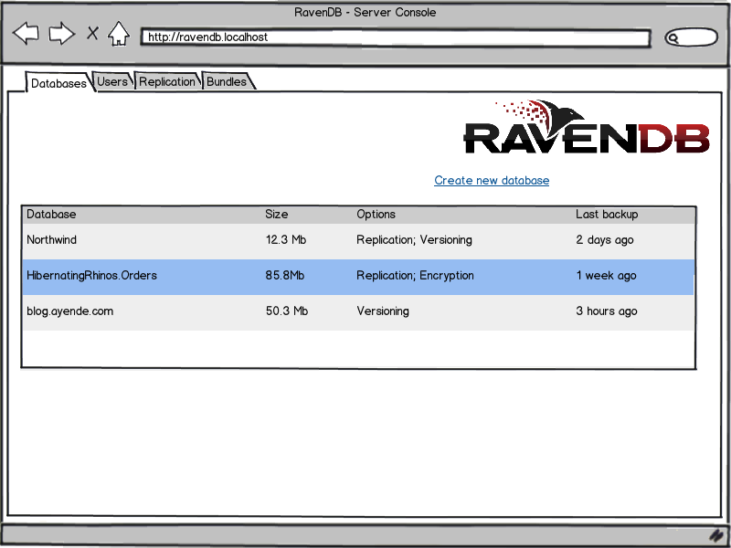

This screen will show all of the databases (except for the default one), including some details about the actual database (last backup, options selected when creating it). Double clicking on the row would take you to the studio for this database.

Creating a new database:

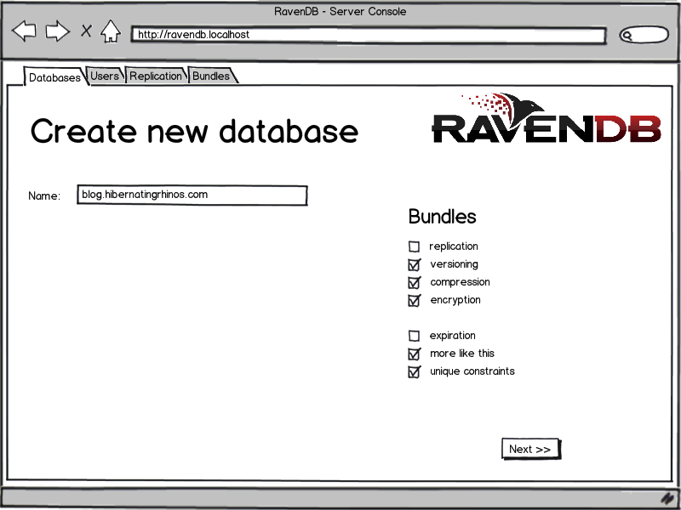

This creates the new database with the specified name, along with selecting the appropriate bundles to install.

Note that bundle selection is *fixed* at the time of the database creation and cannot be modified at a later point in time.

# Replication

The replication tab allows you to configure the replication option and look at the replication status for all of the replication capable databases in the server. An example of how this can look like is:

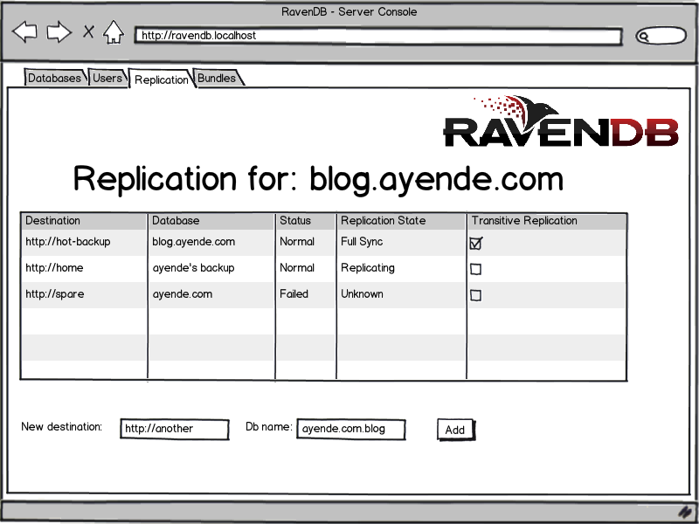

# Users Management

By default, the Server Console will be configured to use mixed mode auth. If you have a windows login, we will use that, but we also support the option of custom user (OAuth).

This will allow us to generate users which can then be granted access to specific databases. This should allow us to provide:

* Name, username, email
* Password

Emails may be used at some point to send notifications / alerts, but are not mandatory.

# Encryption

The Server Console will allow configuring a database to use Encryption both at the doc store level and the index level.

Things to figure out, how do we protect the key? How does this plays with backups? Remote backups?

# Compression

Allow to specify that indexes and documents will be stored compressed.

# Indexing Scheduling

This is a RavenDB enterprise feature, allowing to give more weight to indexes, so they would be index before others.

# Relational Database Integration

In here we

# Bundles UI

All the bundles should have some UI in here, allowing configuring them for their respective databases. For example, setting out what documents the versioning bundle is going to version, and how much, etc.

# Backups

The Server Console will keep track of backups and will allow to configure auto backups to an S3 account for cloud backup.

# Look & Feel

We will use the ravendb.net website look and feel for the Server Console.